**Jiamu ‘s report**

1. **Examine the prevalence and frequency of suicide-related hashtags used by Generation Z individuals on major social media platforms.**

The twitter dataset is first cleaned and preprocessed to remove invalid values in order to obtain input for training. The structured dataset is first obtained, and the imbalance in the dataset is solved by using an oversampling method, and then certain preprocessing is performed to obtain the following data:



From the results, it appears that Generation Z young people may be more lonely than other age groups. Negative emotions such as "low self-esteem," "anxiety," and "depression" are the most recent concerns. The number of social platforms used has been shown to have a strong positive correlation with "depression" and "anxiety".

1. **To analyze the linguistic characteristics, mood and emotional tone of suicide-related posts and comments among Generation Z individuals.**

According to the analysis of the top 20 words in terms of frequency, it can be found that insomnia, feelings, anxiety, fatigue and worry are often present, which also shows that young people are more prone to "depression" and "anxiety" than other age groups.

1. **To explore social network dynamics and information diffusion patterns related to suicide discourse on social media.**

With regard to social network dynamics and information diffusion patterns, I make the following four points in summary:

Speed of information diffusion: The instantaneous and widely distributed nature of social media allows suicide discourse to spread rapidly in a short period of time. A single suicide message posted may be retweeted and shared by many people in a short period of time, expanding its reach.

Social network effect: Users on social media often form social networks with other users, which may consist of family, friends, colleagues, or people with common interests. When one user posts a suicide message, the message may spread quickly through the social network and affect many more people.

Emotional contagion effect: Suicidal words may elicit an emotional response from others, especially those who are susceptible to suicide. They may feel emotions such as sadness, despair or anxiety, and may be affected by suicidal behavior.

High-risk groups: Certain groups are more susceptible to suicidal discourse, such as people with mental health problems, friends and family of suicidal individuals, or individuals who have been bullied. These groups may be more likely to be exposed to and influenced by suicidal discourse on social media.

**d.model**

CNN, as one of the typical models in deep learning, was initially applied to tasks in the direction of computer vision. With the further development of deep learning, several studies have shown that this network model can also be used in the field of natural language processing to achieve good results in natural language processing.

In order to implement a deep learning model for fine-grained microblog sentiment classification, this paper improves the CNN model based on sentence classification for the following two reasons. On the one hand, the traditional model does not remove the non-essential sentiment factors of the object to be evaluated when training the word vector, which tends to degrade the representativeness of the feature matrix. On the other hand, the length of the text content is limited to the number of features it contains. In this paper, we add different scales of convolutional kernels to the traditional CNN model to perform different levels of feature representation.

In this paper, we add different scales of convolutional kernels to the traditional CNN model for feature extraction at different levels. The basic part of the model includes input layer, multi-core convolutional layer, pooling layer and dual fully connected layers.

Theschematic diagram of the network structure is shown below:

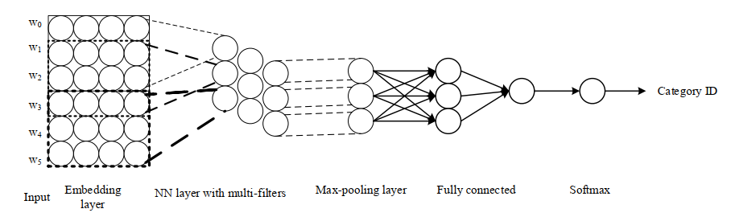

The experiment is conducted at both chapter level and sentence level, i.e., each tweet is used as a training data and the tweets are split into sentence level data for sentiment category labeling. Since the proportion of data labeled as "none" is large, in order to reduce the influence of irrelevant sentiment category data on the experimental results, this model only experiments on sentiment-related data, i.e., data labeled with seven sentiment categories.

The statistics of the data categories in the training and test sets are shown in Fig.

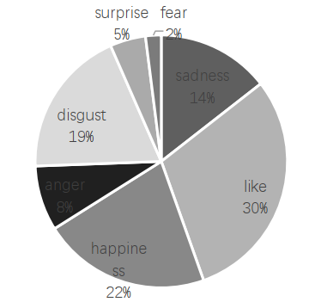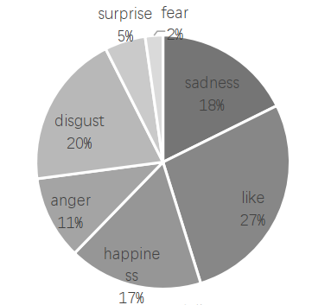

The two metrics, accuracy and error, are tracked in real time during the training process, and the results are shown in Fig. From the trend of the curves, it can be seen that the accuracy and error of the classification model, after several iterations, both reached the convergence state. The accuracy is stable at about 85% and the error is stable at about 0.15, which indicates that the model The model training has achieved good results.

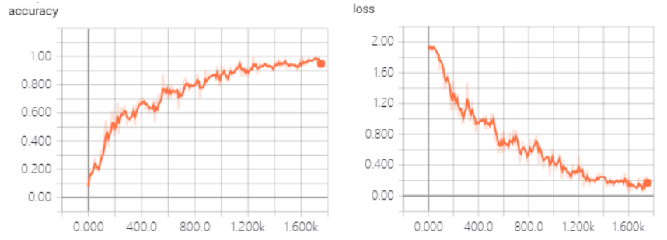

1. **interpretation:**

**(A) Relationship between social media exposure style and adolescents' negative emotions**

Focused exposure and unconscious exposure to social media were combined into a new variable, social media exposure, and 20 questions from the UCLA Loneliness Scale were combined to form the loneliness variable. Controlling for independent variables such as age, gender, place of birth, and whether single-parent family, the R-squared did not change significantly, and the significance of ANOVA was 0.014<0.05,and focused exposure had a very weak positive correlation with loneliness.

The 20 items of the Adolescent Anxiety Scale were summed and standardized to create a new variable for anxiety. The correlation between the anxiety variable and focused exposure was tested and yielded a sig value of 0.038, which was less than 0.05, and therefore had a significant correlation. The correlation coefficient was -0.084, thus anxiety was significantly and negatively correlated with focused exposure. Similarly, the correlation between the anxiety variable and unconscious exposure was tested and yielded a sig value of 0.00, which was less than 0.05, and a correlation coefficient of 0.152, thus adolescent anxiety had a significant positive correlation with unconscious exposure to social media.

The 14 entries of the adolescent suicidal ideation scale were summed and the reverse scoring questions were processed to create the variable adolescent suicidal ideation. The correlation between adolescent suicidal ideation and focused exposure and unconscious exposure was found to be 0.00, less than 0.05, with a negative correlation coefficient, and 0.049, less than 0.05, with a significant negative correlation; the significant value of unconscious exposure to social media and adolescent suicidal ideation was found to be 0.049, less than 0.05, with a significant positive correlation.

**(B) Differences in the relationship between social media exposure and adolescents' negative emotions**

1. Social media exposure exacerbates adolescents' more prevalent loneliness

Loneliness is more common among adolescents, with more than 98% of the adolescents surveyed showing loneliness, and most of them have a high degree of loneliness. Social media exposure was significantly and weakly correlated with adolescents' loneliness, and social media exposure influenced adolescents' loneliness to a degree of 10% to 15%. Both unconscious exposure and focused exposure increased loneliness, with unconscious exposure having a slightly greater effect on loneliness than focused exposure.

2. Unconscious social media exposure is positively associated with adolescent anxiety

Adolescents' anxiety was less common, but still 6.0% of the respondents showed anxiety, and the anxiety level was lighter overall. Focused social media exposure was significantly and negatively associated with adolescent anxiety, while unconscious social media exposure was significantly and positively associated with adolescent negative emotions. Focused social media exposure was able to influence adolescents' anxiety from 8.4% to 23.0%, and unconscious social media exposure was able to influence adolescents' anxiety from 15.0% to 30.4%. The more focused the social media exposure, the lower the anxiety of adolescents, and the more unconscious the social media exposure, the higher the anxiety of adolescents.

3. Social media exposure is significantly associated with adolescent suicidal ideation

Adolescents' suicidal ideation was generally positive, and a very small percentage (0.073%) of adolescents had negative suicidal ideation. Although the percentage is low, it still needs to be given high priority. Focused social media exposure was significantly negatively correlated with adolescent suicidal ideation, and unconscious social media exposure was significantly positively correlated with adolescent suicidal ideation. Focused social media exposure influenced adolescent suicidal ideation to a degree of 15.1% to 21.4%. The more focused the social media exposure, the lower the suicidal ideation among adolescents. Focused social media exposure, after controlling for demographic information variables, influenced adolescents' suicidal ideation to a degree ranging from 12.6% to 18.7%. The more unconscious the social media exposure, the higher the adolescent suicidal ideation. Notably, unlike loneliness and anxiety, the effect of social media exposure on adolescent suicidal ideation must also take into account other basic information about the adolescent.

1. **conclusion**

Social media has extended the "offline" social activities to the "online". In particular, the widespread use of instant messengers has made it easier to socialize online. As a result, "excessive contact creates a habitual psychological hunger, so that whenever you leave your communication device, and whenever you don't receive a timely response, you feel panicked. The relatively weak self-control of teenagers makes it easier for them to develop a dependence and desire for social media, which is reflected in the fact that the viscosity of using instant messaging social software is significantly higher than that of other types of social software. This also shows that there is a strong correlation between adolescents' perception of the Internet and their online behavior. In general, adolescents should reduce the use of social media, especially unconscious social media. On the one hand, adolescents should pay attention to control the intensity and frequency of social media use, focus on realistic study and life, and enrich outdoor cultural activities. On the other hand, teenagers should try to avoid using social media aimlessly to pass time, and should make good use of social media to start their study and work.